Dear Kindergarten Families, March 20, 2017
The students enjoyed their Superstar party. They all love their snuggly items. We watched Dr. Seuss movies and they had their snack. 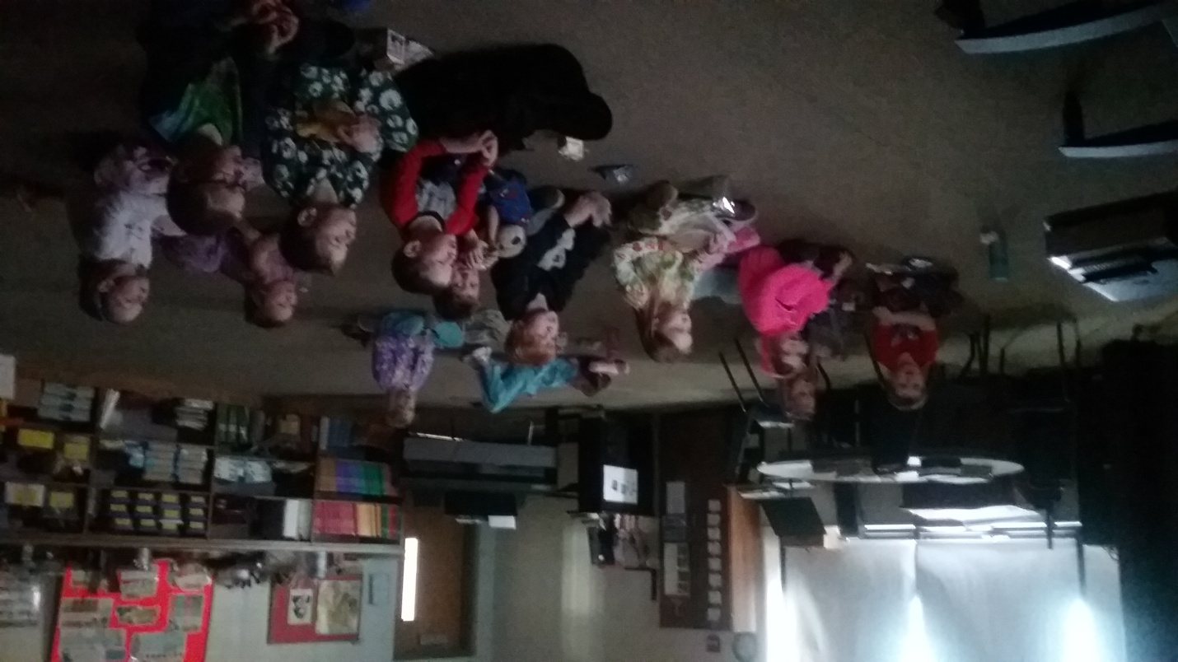
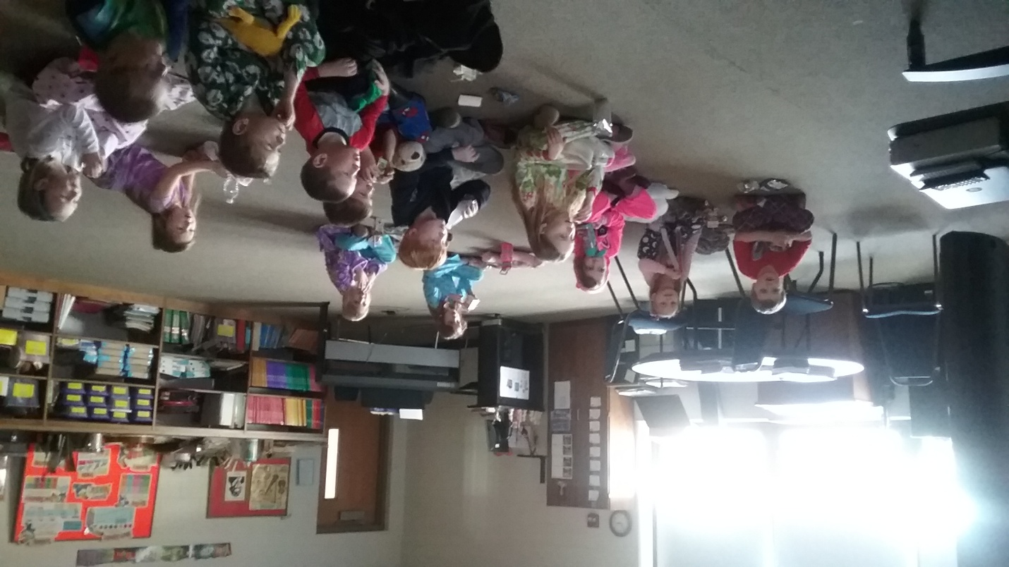
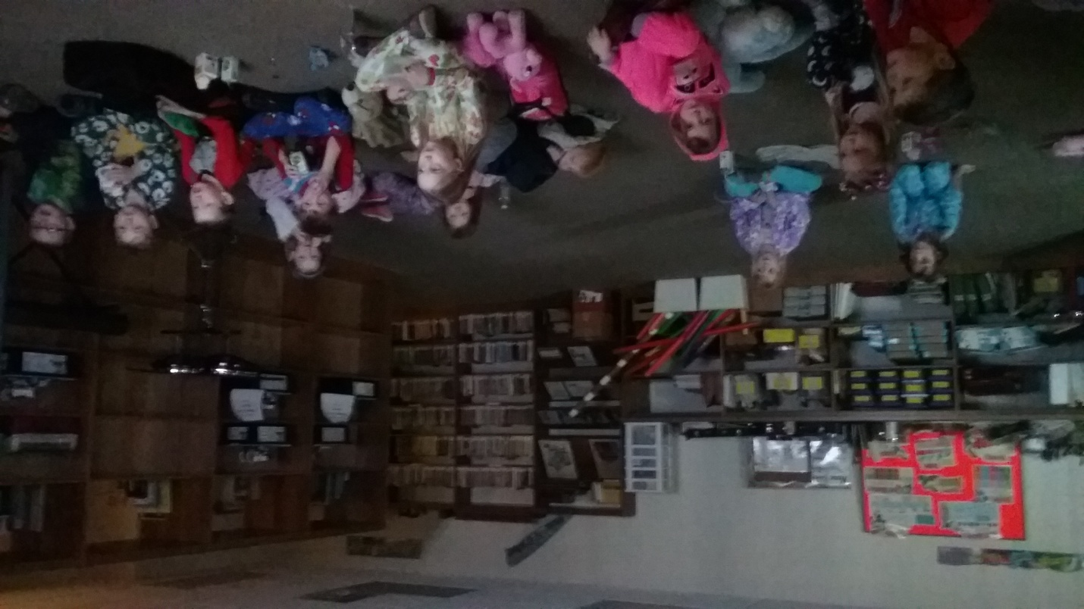
In Math the students took the graph and compare chapter test. I will be sending the Math Tests home for you to sign and return the week we get back from Spring Break. For stations the students measured themselves with unifex cubes. They explored compacity by pouring water into different sized cups. One of the stations introduced the students to measuring circumference with string.
Understand the relationship between quantities and whole numbers up to 31.
K.1.1.1 Recognize that a number can be used to represent how many objects are in a set or to represent the position of an object in a sequence.
K.1.1.2 Read, write, and represent whole numbers from 0 to at least 31. Representations may include numerals, pictures, real objects and picture graphs, spoken words, and manipulatives such as connecting cubes.
K.1.1.5 Compare and order whole numbers, with and without objects, from 0 to 20.
Code Benchmarks K.3.2.1 1. Use words to compare objects according to length, size, weight and position. For example: Use same, lighter, longer, above, between and next to. Another example: Identify objects that are near your desk and objects that are in front of it. Explain why there may be some objects in both groups.
K.3.2.2 2. Order 2 or 3 objects using measurable attributes, such as length and weight.

In Language Arts we read “Green Eggs and Ham”, “One Fish, Two Fish, Red Fish, Blue Fish”. The girls and boys made Dr. Seuss hats. We did the letter “Ee” workbook page. We completed a Quizziz Dr. Seuss quiz online. The students picked their favorite Dr. Seuss book and on Seasaw they supported their pick choice. On Thursday Mrs. Zolondek read, “If You Give a Mouse a Cookie,” and “Who Took the Cookie from the Cookie Jar.” Friday, she read, “Chameleon, Chameleon.” In writing/journaling this week we practiced writing, “I said” sentences.
In Science Trinity talked about her project. The students went to look at the science fair projects.
In Social Studies we talked about from farm to table. I read the book, “The Milkmakers.” The students picked a product and had to draw a picture of that product getting from the farm to the table.
In Religion the boys and girls did a wonderful job participating at Mass.
In Art the topic was pointillism and the students used markers to do a cross with color. The crosses are on display in the classroom.
I had a fever on Thursday and Friday. Mrs. Zolondek did a great job substituting for me. I heard the students did a wonderful job for her. She complimented all the students.
The Kindergarten webpage is http://kindergarten-sjbschool.weebly.com . You can view the weekly Kindergarten letter on Tuesday each week. I will also email letters to you on Tuesday.

If you have any questions please contact me at (651) 437-2644. God Bless You, Love Mrs. Huneke

