Dear Kindergarten Families, March 6, 2017
The students earned a Superstar party. They choose a movie/pajama party with other snuggly item as desired. We will celebrate the party on Wednesday afternoon. We will wait for snack until the party. You may send a drink to go with the snack or they may have milk; please do not send caffeine pop. Students should not wear pajamas to school; send them in your son’s or daughter’s back pack. If your child doesn’t want to wear pajamas, this is optional.
In Math we worked on using graphs to compare numbers. I assigned comparing numbers for Prodigy. During Stations the students played high card, made a March calendar, used a number line to compare numbers, and played Prodigy. We compared numbers by putting them on a hundred chart and talking about which was the greatest and least. Monday, March 6 we will take Chapter 12 test on comparing numbers. After comparing numbers we will work on measurement.
Understand the relationship between quantities and whole numbers up to 31.
K.1.1.1 Recognize that a number can be used to represent how many objects are in a set or to represent the position of an object in a sequence.
K.1.1.2 Read, write, and represent whole numbers from 0 to at least 31. Representations may include numerals, pictures, real objects and picture graphs, spoken words, and manipulatives such as connecting cubes.
K.1.1.3 Count, with and without objects, forward and backward to at least 20.
K.1.1.4 Find a number that is 1 more or 1 less than a given number.
K.1.1.5 Compare and order whole numbers, with and without objects, from 0 to 20.
Code Benchmarks K.3.2.1 1. Use words to compare objects according to length, size, weight and position. For example: Use same, lighter, longer, above, between and next to. Another example: Identify objects that are near your desk and objects that are in front of it. Explain why there may be some objects in both groups.
K.3.2.2 2. Order 2 or 3 objects using measurable attributes, such as length and weight.

In Language Arts we listened to Jolly Phonics video. It emphasizes the sounds for more than the alphabet (or, ar, ing, er, ir, ch, th, wh, sh, long vowel sounds etc.) We read Dr Seuss’ book “Hop on Pop.” They played the sight word game again “ A Tisket A Tasket A Word In a Basket” that they skipped around a circle and dropped a sight word behind a classmate to see if they could read it. Our sight words were again “all” and “she”. Our sound was “Ee” and will be again this coming up week. This week Thursday Jean Beskau will not be here for stations. I will be making cookies and reading the story, “If You Give a Mouse a Cookie.” I am looking for a parent volunteer in the morning from about 9:00 until 11:00.

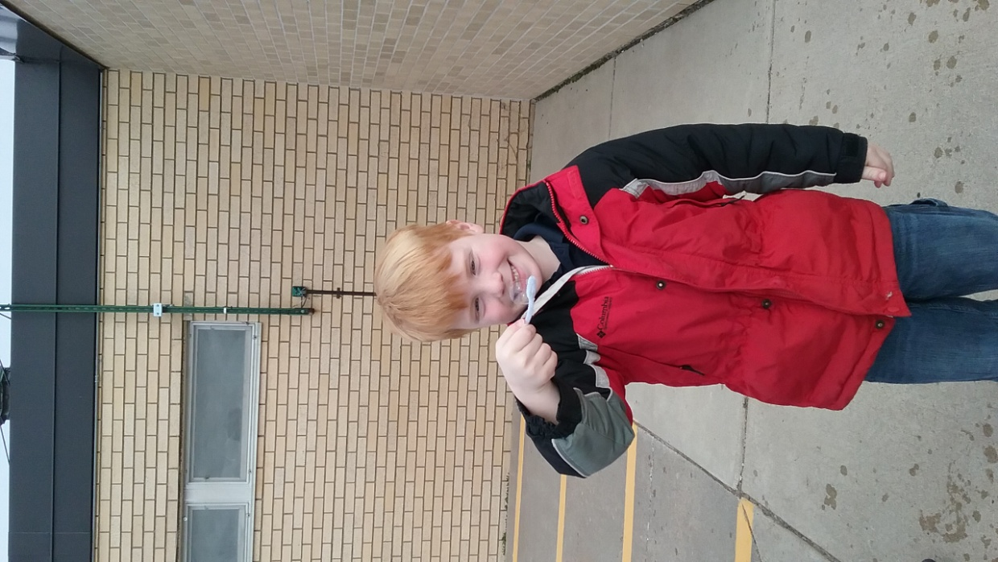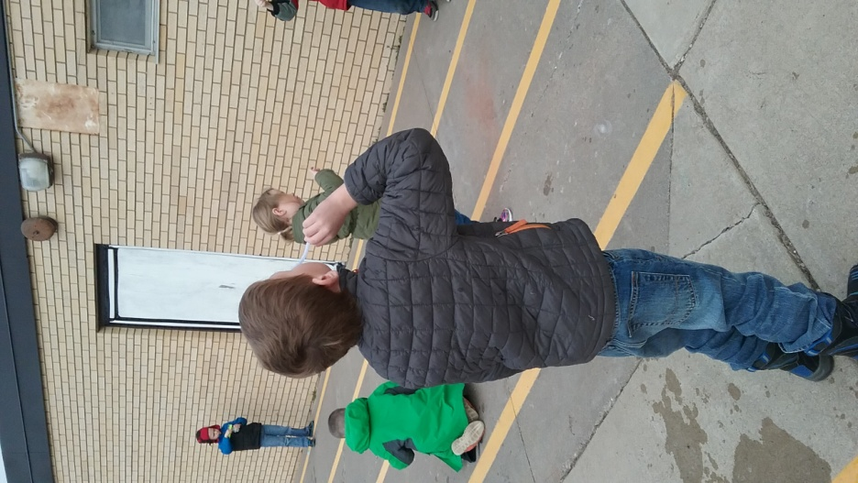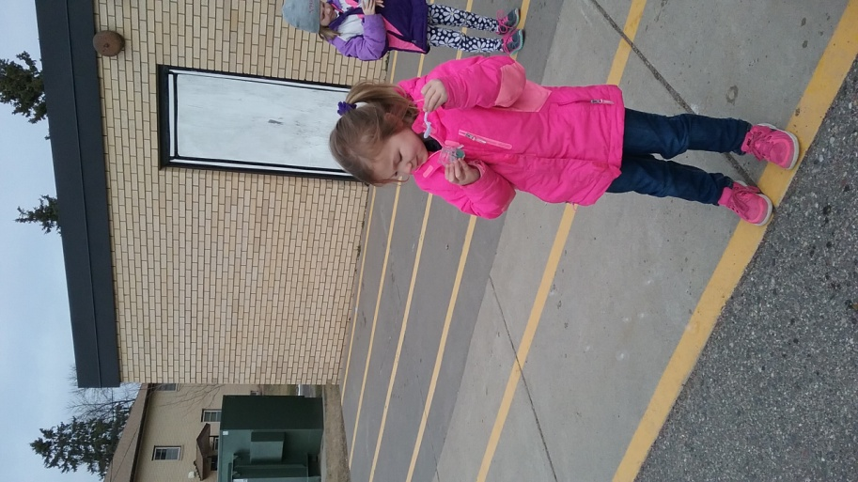
In Science we last week we did a bubble experiment and this week we made homemade bubble solution that worked well for us. It was ¼ cup water, ½ tsp Karo syrup and ½ tsp dawn dish soap. We gently mixed the solution and made a pipe cleaner into bubble wand. This activity went with our decodable reader story, “Make It Pop.”
We made a video for Sheila Benning thanking her for teaching us about dental health. (The video I emailed to everyone.)
In Religion we have been practicing for our Mass, talking about the apostles, and talking about what we are going to do for Lent. We watched the VeggieTales movie, “Jonah and The Whale.”- This is the story based on the reading for our Mass Wednesday. ***Our Mass is this Wednesday, March 8. ***
The Kindergarten webpage is http://kindergarten-sjbschool.weebly.com . You can view the weekly Kindergarten letter on Tuesday each week. I will also email letters to you on Tuesday.

If you have any questions please contact me at (651) 437-2644. God Bless You, Love Mrs. Huneke

